**Engineering Specification**



**SPEC, CDM/CMFS CASE TEMPERATURE EFFECT ON DENSITY** **SPEC, MANIFOLD HY CW-2M**

**ER-20027172**

**Revision: AD** **C**

**Number of Pages: 10**

**Comments:**

**Originator:** SAS

**Approved:** SAS

|  |  |  |  |  |  |
| --- | --- | --- | --- | --- | --- |
| **Rev** | **ECN** | **Description** | | **Approval** | **Date** |
| AA | 1048412 | | Release to Production | SAS | 06/02/2014 |
| AB | 1048494 | | Updating Spec format and equation nomenclature. Correcting A4 Coefficient values. | SAS | 08/01/2014 |
| AC | 1054187 | | Updated A4 coefficients for Partial Pen Case Weld Design Change. | GPS | 5/20/2016 |
| AD | 1059889 | | Added CMFS025-150. | JDN | 6/13/2017 |
|  |  | |  |  |  |
|  |  | |  |  |  |
|  |  | |  |  |  |
|  |  | |  |  |  |
|  |  | |  |  |  |
|  |  | |  |  |  |
|  |  | |  |  |  |
|  |  | |  |  |  |
|  |  | |  |  |  |
|  |  | |  |  |  |
|  |  | |  |  |  |
|  |  | |  |  |  |
|  |  | |  |  |  |

**1.0 Scope of this specification:**

This document discusses the CDM case temperature effects on the density measurement and the methods of obtaining the calibration coefficients.

**2.0 Terms, Definitions and Abbreviations**

2.1. *Coefficient*  Unique values input into the CDM used in calculating the fluid density

2.2. *CDM*  Compact Density Meter

2.3. *RTD*  Resistive Thermal Device

2.4. *UUT*  Unit under test

2.5. *C22*  An austenitic nickel-chromium-molybdenum-tungsten alloy

1. **Background - MMI Density Equations**
   1. Coriolis Density Equation:   
      The density equations are linear and consist of measured values and calculated coefficients. It includes the corrected time period and the corrections for temperature, pressure, and flow. The Coriolis density equations are:

|  |  |
| --- | --- |
| $ρ=\left(C_{1}∙τ_{c}^{2}+C_{2}\right)-K_{P}∙P_{g}- \frac{FD}{{10}^{9}}{∆t}^{2}$*,* | (1) |
| $τ_{c}^{2}= τ_{m}^{2}\left(1-\frac{D_{T}}{10,000}T\right)$*,* | (2) |
| where: |  |
|  |  |
| D1 – C1·K12 |  |
| Tube temperature ($°C$) $FD= Flow effect on density$ $\left(\frac{\frac{gm}{{cm}^{3}}}{{μs}^{2}}\right)$ $D_{T}=$   Flow tube temperature effect on * 2*()    Pickoff time delay (s)      Fluid pressure (psig) |  |
| $K1=$ Tube Period for air at 0ºC (s)  Tube Period for water at 0ºC (s)  Density of Air $\left(\frac{gm}{{cm}^{3}}\right)$ $D2=$  Density of Water $\left(\frac{gm}{{cm}^{3}}\right)$ $τ_{c}^{2}=$  Temperature corrected time period squared (s2)  () |  |
| * 1. CDM Density Equations   The CDM density equations are similar to the Coriolis density equations, where they are linear and compensate for the effects of fluid temperature, pressure, and flow. The CDM also incorporates an extra compensation for the effect of ambient temperature. Here it can be noted that A1, A2, A3, A5 and A6 are equivalent to the DT, C1, C2, KP and FD coefficients of the Coriolis equations respectively. The CDM density equation can be broken down into sub-equations. The corrected time period equation and CDM density sub-equations are listed below: $τ_{c}^{2}=$ $τ_{m}^{2}\left(1-\frac{A_{1}}{10,000}T\right),$ (3) | |
| $ρ_{T}=\left(A_{3}∙τ_{c}^{2}+A_{2}\right)$, (4) $ρ_{C}={ρ_{T}+A}_{4}\left(T-T_{C}\right),$ (5) $ρ_{P}={ρ_{C}+A}_{5}\left(P_{g}\right)$  **,**  (6) $ρ_{FD}={ρ_{P}-A}_{6}\left(\frac{1}{{10}^{9}}{∆t}^{2}\right),$  (7)   where: | |
| $T_{C}=$ Case Temperature (ºC) $A_{1}$ = Coefficient for tube temperature effect on * 2*()    Intercept of the ** vs. *m*2 curve  Slope of the ** vs. *m*2 curve   Coefficient for ambient temperature effect on density (*tube stress*) $\left(\frac{\frac{gm}{{cm}^{3}}}{ºC}\right)$ $A_{5}=$  Coefficient for pressure effect on calculated density (*tube stiffness change*) $\left(\frac{\frac{gm}{{cm}^{3}}}{psig}\right)$ $A_{6}=$  Coefficient for flow effect on density $\left(\frac{\frac{gm}{{cm}^{3}}}{{μs}^{2}}\right)$ | |
| Equations (3), (5), (6), and (7) are the CDM sub-equations that account for the effects of fluid temperature, ambient temperature, fluid pressure, and fluid flow. Combining equations (3), (4), and (6) and ignoring the effects of the ambient temperature and fluid flow yields the density equation that is used to determine A1, A2, A3, and A5. The equation is written as:  (8)  The A4 and A6 coefficients are known constants and are determined by a case temperature test (discussed below) for A4, and other analytical methods for A6. The case temperature test and A4 are the focus of this document. The final density equation is equal to *FD*, equation (7), and is written below: $ρ_{FD}=A_{3}∙τ_{m}^{2}\left(1-\frac{A_{1}}{{10}^{4}}∙T\right)+A_{2}{+A}_{4}\left(T-T_{C}\right)+A_{5}\left(P_{g}\right)-\left(\frac{A_{6}}{{10}^{9}}{∆t}^{2}\right)$ (9) | |

1. **Case Temperature Effect**The A4 coefficient is determined using a calibrated sensor and running it through a case (ambient) temperature test. During the test the A4 coefficient is set to zero and the density error, due to ambient temperature, is calculated. The equations used in determining A4 are listed below:

$ρ_{calc}=A_{3}∙τ_{m}^{2}\left(1-\frac{A_{1}}{{10}^{4}}∙T\right)+A_{2}+A_{5}\left(P_{g}\right){-A}_{6}\left(\frac{1}{{10}^{9}}{∆t}^{2}\right)$, (10) $ρ_{error}=ρ_{calc}-ρ_{ref}$ 
, (11) $∆T=T-T_{C}$ 
  
 , (12) $P_{g}=\left(\frac{P_{down}+P_{up}}{2}\right)-P_{amb}$  
  
 , (13)

where:

$ρ_{error}$ = Difference in CDM density and the reference density $\left(\frac{gm}{{cm}^{3}}\right)$ $ρ_{ref}$ 
   
 = Reference density as reported from the calibration stand $\left(\frac{gm}{{cm}^{3}}\right)$ $∆T$ 
  
 = Temperature difference between the CDM tubes and CDM case $(°C)$ $P_{g}$ 
  
 = Gauge pressure used in density calculation $(psig)$ $P_{up}$ 
  
 = Fluid pressure before the CDM inlet $(psia)$ $P_{down}$ 
  
 = Fluid pressure after the CDM outlet $(psia)$ $P_{amb}$ 
  
 = Ambient pressure $(psia)$

Equation (10) is equation (9) with the A4 term set to zero. Equation (11) is the density error between the CDM and the reference density. Equation (12) is the difference between the case temperature and the tube temperature. Equation (13) is the gauge pressure of the fluid, where the average of the fluid pressures, before and after the CDM, and the ambient pressure are used to calculate the gauge pressure. The A4 coefficient is the slope of the line created by plotting density error, equation (11), vs. the temperature difference, equation (12). See Fig. 1.

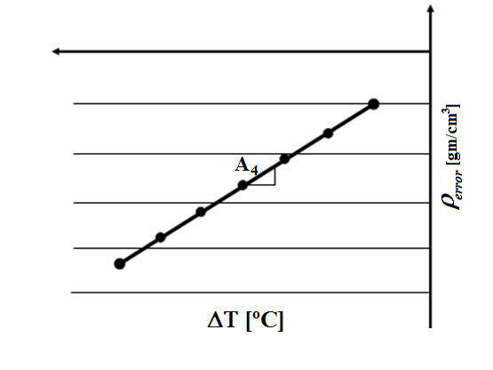

***Fig. 1*** Density error vs. change in temperature difference  
  
The A4 coefficient is assumed to be constant for each sensor material, thus it does not need to be determined with each calibrated meter.

* 1. Test Description

The Case temperature test was performed on both the stainless steel and C22 sensors. The meter was installed into the calibration stand and filled with water. The calibration stand is an enclosed and thermally sealed chamber that controls the fluid and ambient temperatures independently. The test consisted of keeping the flowing fluid temperature constant and increasing the ambient (chamber) temperature from 20ºC to 70ºC, in increments of 10ºC. The test began once the CDM reached the equilibrium point, where the equilibrium point was defined by the stability of the meter’s tube period. At each ambient temperature a sufficient amount (at least 2 minutes) of data was recorded before moving to the next temperature increment. The recorded variables were the fluid pressures before (*Pup*) and after (*Pdown*) the CDM inlet and outlet, ambient pressure (*Pamb*), CDM tube temperature (*T*), CDM tube period (*m*), CDM case temperature (*Tc*), the pickoff time delay (*t*), and the reference density (**ref).

* 1. A4 Coefficient Determination:

The A4 coefficients for both the Stainless Steel and C22 CDM Sensors were calculated using the method described above and are shown in Table 1.   
  
  
Table 1: A4 Coefficients for the CDM/CMFS sensors

|  |  |
| --- | --- |
| Sensor Model | 2 Brace Bar Sensor |
| **CDM100M** | -4.800E-05 $\frac{\frac{gm}{{cm}^{3}}}{℃}$ |
| **CDM100P** | -4.800E-05 $\frac{\frac{gm}{{cm}^{3}}}{℃}$ |
| **CMFS150M/H/P** | -4.800E-05 $\frac{\frac{gm}{{cm}^{3}}}{℃}$ |
| **CMFS100M/H/P** | -5.800E-05 $\frac{\frac{gm}{{cm}^{3}}}{℃}$ |
| **CMFS075M** | -6.600E-05 $\frac{\frac{gm}{{cm}^{3}}}{℃}$ |
| **CMFS050M/H/P** | -7.400E-05 $\frac{\frac{gm}{{cm}^{3}}}{℃}$ |
| **CMFS040M** | -6.400E-05 $\frac{\frac{gm}{{cm}^{3}}}{℃}$ |
| **CMFS025M/H/P** | -8.700E-05 $\frac{\frac{gm}{{cm}^{3}}}{℃}$ |

The slopes of the **error vs. *T* curves (shown in figures 1-3) are positive and represent the ambient temperature effect on the CDM density. The coefficients in Table 1 are negative because A4 is the compensation for the effect that the ambient temperature has on the sensor. The graphed data used to calculate A4 for both the Stainless Steel and C22 CDM Sensors is shown in Appendix 1.

**Appendix 1: Case Temperature Effect Plots**

The following plots show the case temperature effect for the partial pen case weld stainless steel sensors.

Stainless Steel Case Temperature Effect

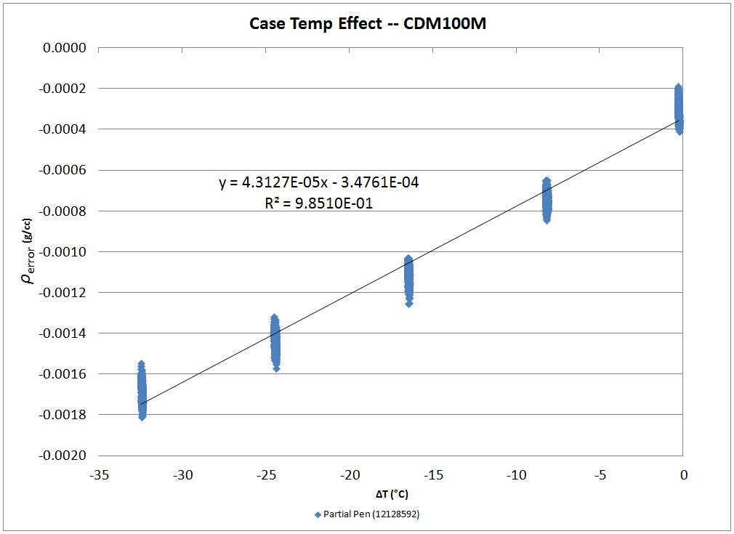

***Fig. 2*** Density error vs. change in temperature difference for Stainless Steel Sensors

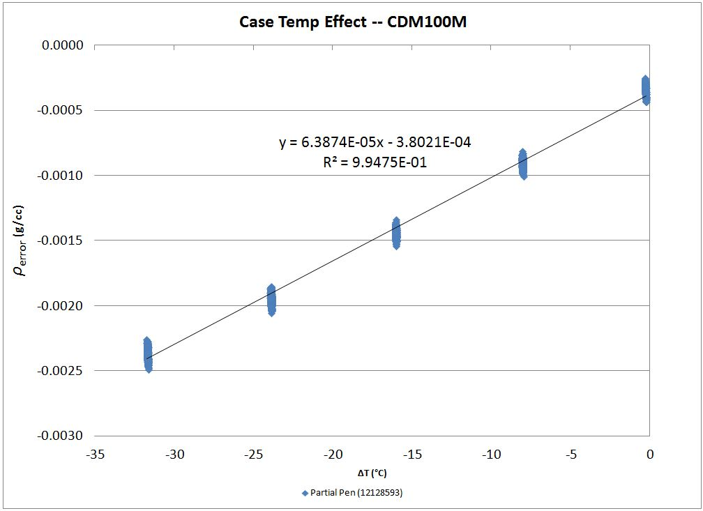

***Fig. 3*** Density error vs. change in temperature difference for Stainless Steel Sensors

The following plots show the case temperature effect for the partial pen case weld C22 sensors.

C22 Case Temperature Effect

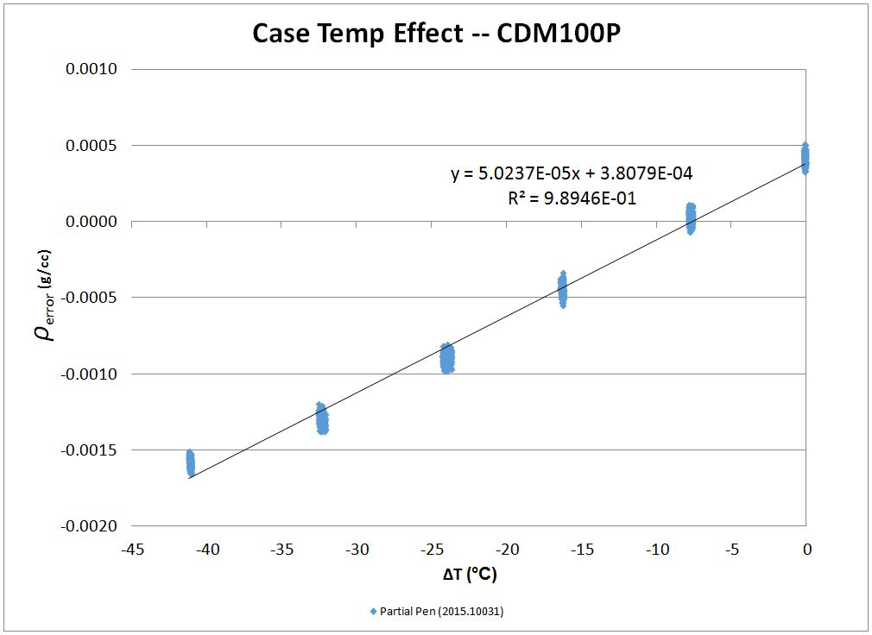

***Fig. 4*** Density error vs. change in temperature difference for C22 Sensors

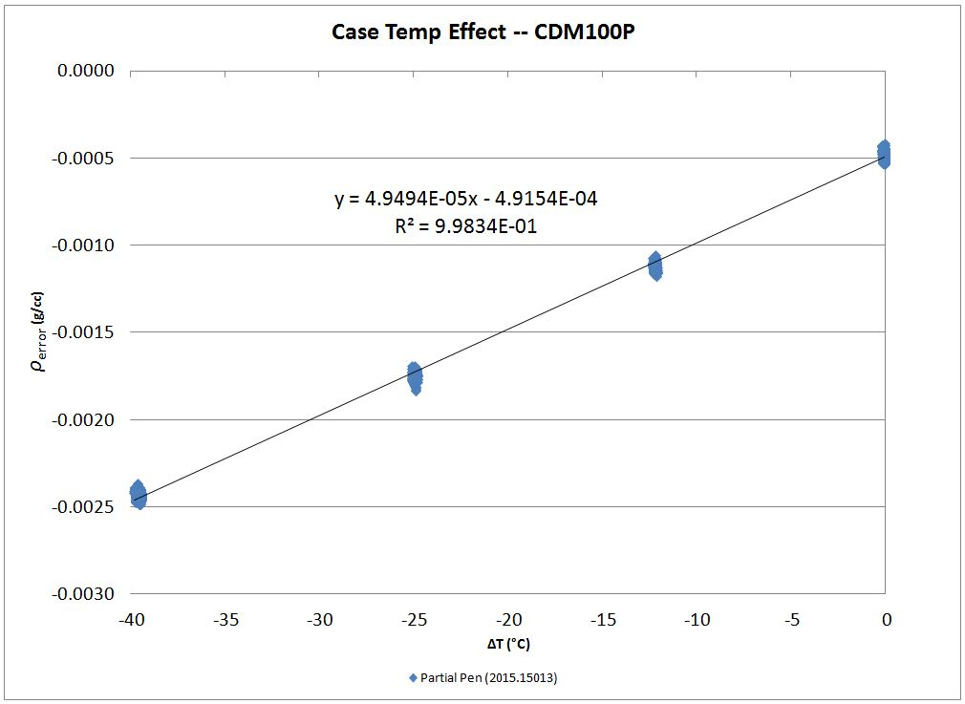

***Fig. 5*** Density error vs. change in temperature difference for C22 Sensors